EMPLOYEE DATABSE MANAGEMENT SYSTEM

By – NIKHIL KUMAR, DEV BHATIA, DHYEY SHAH

CSE - AIML, UNITEDWORLD SCHOOL OF COMPUTATIONAL INTELLIGENE(USCI) GANDHINAGAR, GUJARAT

1. **ABSTRACT**

*This paper aims to summarise the development of a robust employee data management system by using Python programming language and MySQL Database. The primary objective is to make a robust program to increase the speed and reduce system load caused by database management systems. The goal is to achieve robust and secure database management system that can handle large amount of traffic while maintaining performance, making it a feasible solution for database management system.*

1. **INTRODUCTION**

*A database management system (or DBMS) is essentially nothing more than a computerized data-keeping system. Users of the system are given facilities to perform several kinds of operations on such a system for either manipulation of the data in the database or the management of the database structure itself. Database Management Systems (DBMSs) are categorized according to their data structures or types.*

*There are several types of databases that can be used on a mainframe to exploit inverted list, hierarchic, network, or relational.*

*Mainframe sites tend to use a hierarchical model when the data structure (not data values) of the data needed for an application is relatively static. For example, an Employee Database Management System (EDMS) database structure always has a high-level employee information, and several levels of sub information. The structure of the data for an Employee Database rarely changes, and new data elements (not values) are rarely identified.*

*Hierarchical and relational database systems have common benefits. RDBMS has the additional, significant advantage over the hierarchical DB of being non-navigational. By navigational, we mean that in a hierarchical database, the application programmer must know the structure of the database. The program must contain specific logic to navigate from the root segment to the desired child segments containing the desired attributes or elements. The program must still access the intervening segments, even though they are not needed. The remainder of this section discusses the relational database structure.*

*Relational databases include the following structures:*

*Database: A database is a logical grouping of data. It contains a set of related table spaces and index spaces. Typically, a database contains all the data that is associated with one application or with a group of related applications. You could have a payroll database for an example.*

*Table: A table is a logical structure made up of rows and columns. Rows have no fixed order, so if you retrieve data you might need to sort the data. The order of the columns is the order specified when the table was created by the database administrator. At the intersection of every column and row is a specific data item called a value, or, more precisely, an atomic value.*

*Keys: A key is one or more columns that are identified as such in the creation of a table or index, or in the definition of referential integrity. A table can only have one primary key because it defines the entity. There are two requirements for a primary key: It must have a value, that is, it cannot be null and it must be unique, that is, it must have a unique index defined on it.*

1. **METHODOLOGY**

*The program created in this project is Menu-driven program. Menu-driven programs are interactive programs that take input from the users and perform actions according to their choice. While making the applications easy to use menu driven programs also make them unambiguous by giving fixed choices to the user. With this approach, the user can select an operation from a menu and provide input as needed. The program acts according to the input taken from the user. All the data required for completing the tasks are taken from the user.*

*We can see many applications of the Menu-driven programming approach in our day-to-day life. Microprocessor-controlled appliances like washing machines, microwaves, etc. have systems that follow the same approach. ATMs (Automated Teller Machines) and vending machines also use a menu-driven programming approach. Many software systems also follow the same approach for implementing their functionalities. All these systems take input from users from the single keystrokes and perform actions accordingly.*

***Advantages:***

* *Menu-driven programs have a simple, user-friendly, and interactive interface.*
* *These are self-explanatory and users can easily operate the systems.*
* *Menu-driven systems are less prone to errors as they have limited options and users give input in single keystrokes.*

1. **WORKING**

***Simple Block Diagram:***

**Simple flow
**

*There are 4 primary choices in this program:*

*Add Data: To add employee data in database. The Program takes required input from user and add the given information in database.*

*View Data: To view the data present in database. The Program takes specific input (employee id or name) to search for specific information related to employee or show all the information present in database. It uses python tabulate module to form table and show the result as per given input.*

*Update Data: To update data that is already present in database. The program takes employee id as input and show all the possible updates that can be performed on information.*

*Delete Data: To delete specific data present in database. The program takes employee id as input to show employee information if exist, and ask for confirmation to delete it. Once confirmed by user, it deleted the data from database.*

*The database itself is split in 3 tables. It is done so to separate different kind of information related to employee from one another. The tables are divided as:*

* *Main Info table: To store major information related to employee such as name, division, position etc.*
* *Finance Info Table: To store the pays related to employees.*
* *Personal Info Table: To store other information related to employees such as dob, address, contact information, etc.*

*The following is sample execution of program to view data stored in database:*

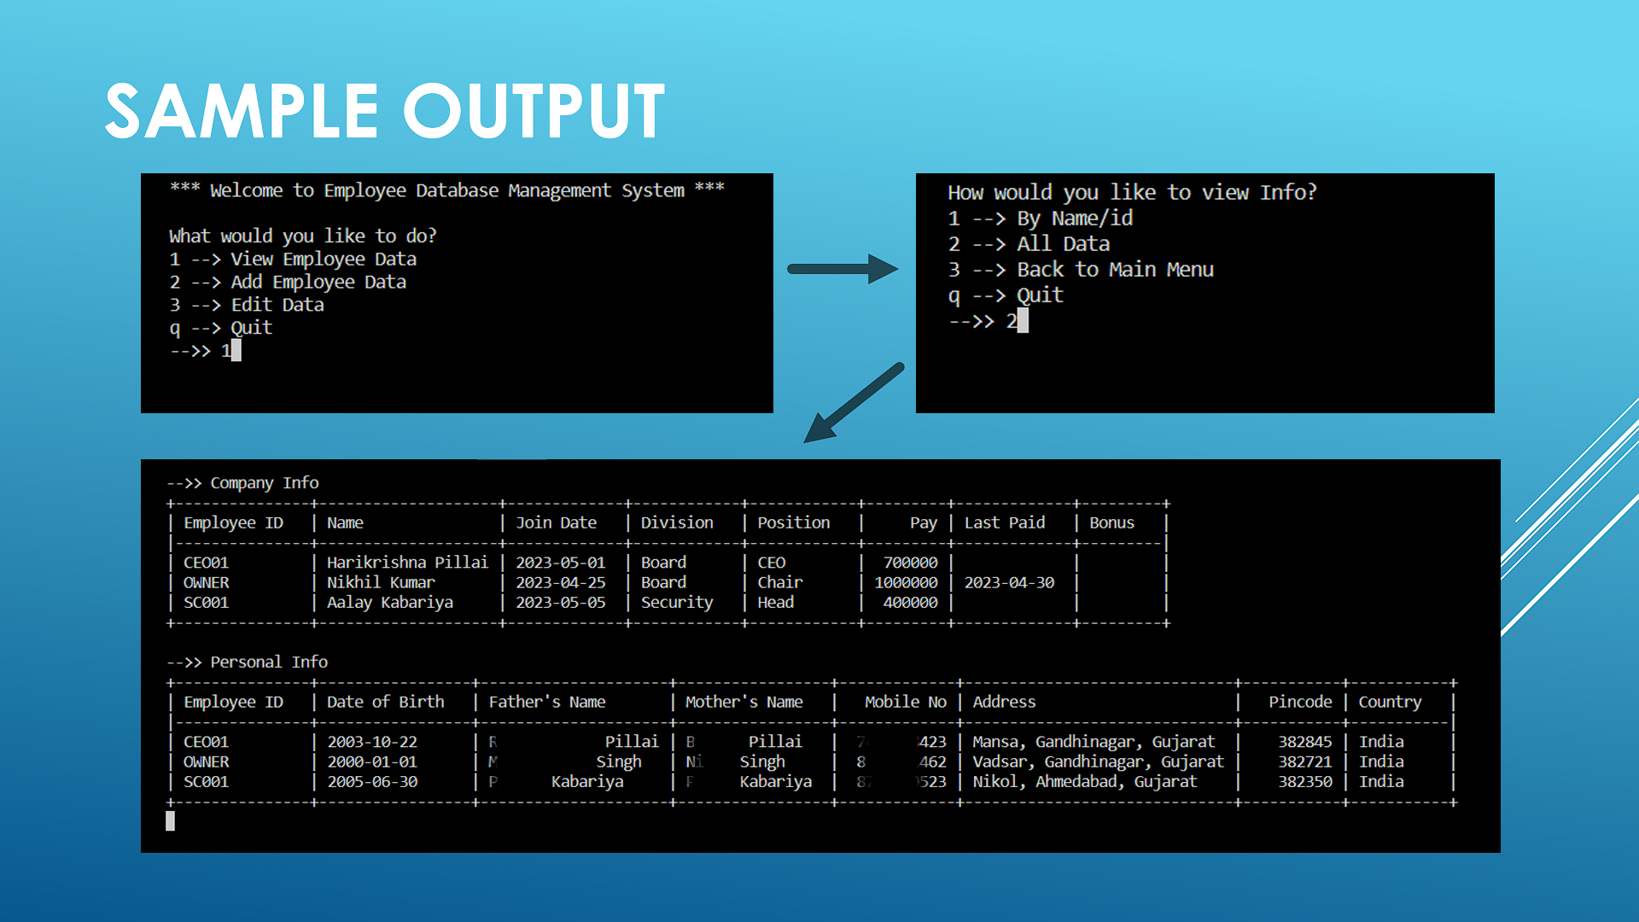

*View menu
*

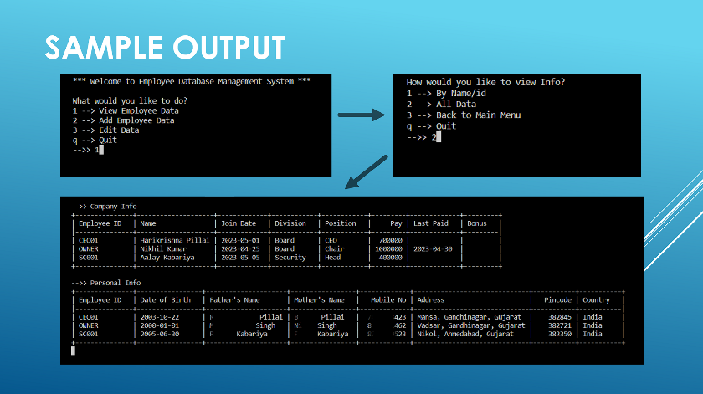

1. **MODULES**

*All the modules used in the project are available in Python Package Index (PyPI).*

* ***mysql-connector-python****: MySQL Connector/Python enables Python programs to access MySQL databases, using an API that is compliant with the Python Database API Specification.*

*It is the core module used in the project. It is responsible for performing all operations on MySQL Database present on remote server.*

* ***tabulate****: Python tabulate module is a simple list to table convertor to view data in tabular form.*

*It is used in the project to display information at various places while using the program.*

* ***os****: The OS module in Python provides functions for interacting with the operating system.*

*It is used in program to organize the cli menu and clean at times when required.*

1. **RESULT**

*After careful examination, we noted that the performance of our program, Employee Database management System, is dependent on internet connectivity speed and bandwidth. There was no visible performance issue or bottleneck issue due to code on local system. The result shows high fetch (read) and write speed from and to database and local system.*

*Overall, the program can definitely help small and medium scale institutions/organisations to manage employee data safely and quickly. Having accessibility from any place and cross-platform support enhances the attribute of the program.*

1. **CONCLUSION**

*This program is one of the constructive methods to implement and handle relational data with enhanced features. The method is fast, reliable and easy to use. It can be implemented not only for employee database, but also in other field such as school database, library database, etc.*

*The data stored in MySQL Database Server is already very secure. Additional security measures can be used to enhance data security such as using SSL encryption certificate to connect between client and server or by binding client IP to server if client supports static IP.*

*Overall, MySQL Database can store huge amount of data in server, can be up or down-scaled depending on resource usage and the program is responsive and quick. GUI can be added to make it more appealing and easier to use for general public.*

1. **REFERENCES**